|  |  |  |  |
| --- | --- | --- | --- |
| 1 | | 93,576.0 | |
| NUMERO DE FRONTERAS | | ENERGIA AGREGADA | |
|  | | | |
| SI | | 02/01/2022 | |
| CONTRATO | | VENCIMIENTO CONTRATO | |
|  | | | |
| 275,067,704 | 124 | | 11,729,491 |
| INGRESO 2021 | DÍAS CERTIFICADOS 2021 | | ENERGIA RESPALDADA 2021 |

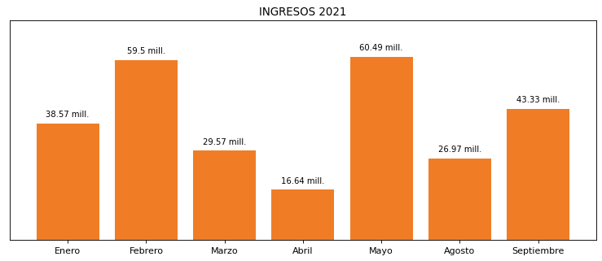

|  |
| --- |
| **PRAXAIR YUMBO**  USUARIO |

|  |
| --- |
| **Mateo Porras**  Ejecutivo de cuenta |

|  |
| --- |
| **Antonio Sayago / 0 / Antonio.Sayago@linde.com**  Primera fecha: PUNTO FOCAL |

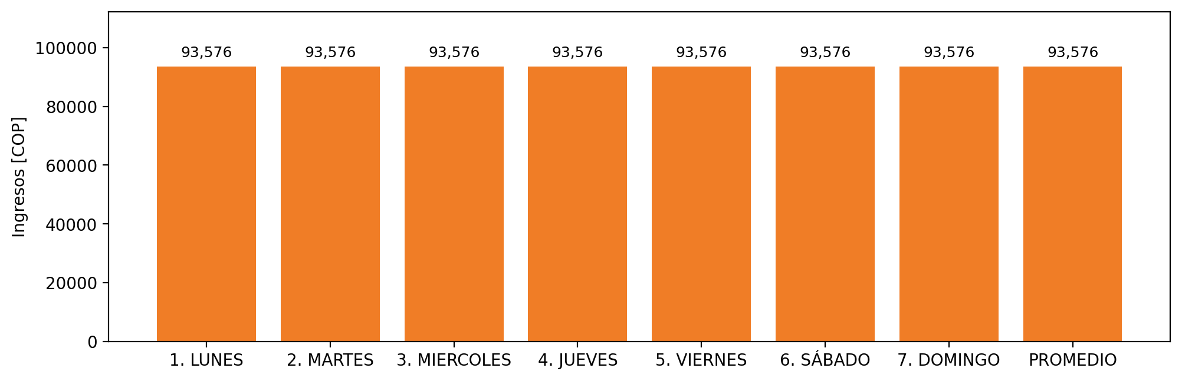

|  |  |  |  |  |  |  |  |  |  |
| --- | --- | --- | --- | --- | --- | --- | --- | --- | --- |
| **FRONTERA COMERCIAL** | **TIPO DDV** | **COD SIC** | **PREDIO** | **PROMEDIO** | **MARGEN** | **ÚLTIMA DESCONEXION** | **DÍAS CERTIFICADOS** | **ACTUALIZACION** | **PROXIMA PRUEBA DDV** |
| PRAXAIR YUMBO | Frt30838 | Frt11003 | Prd00945 | 93,576 | 59,87 | 2021-08-08 | 32.0 | 2021-11-24 | 2021-12-31 |